Practical - 2
Practical Title: Semantic HTML5 Pages with Accessibility-Ready Structure

Problem Definition: Develop static HTML5 skeletons for at least 10 StudentHub pages such as Home, About, Register, Login, Dashboard, Events, Profile, Contact, Admin, FAQ, and Feedback. Use semantic tags and accessibility-friendlystructure.

Theory

Are semantic tags such as header, nav, main, section, article, aside, and footer used properly?
Answer: Semantic elements provide meaningful tags that clearly describe their purpose, improving readability, accessibility, and SEO for both humans and browsers.
- Clearly define the role and content of elements.
- Improve code readability and structure.
- Enhance accessibility for screen readers.
- Help browsers and search engines understand page content.
- Examples include <form>, <table>, <article>, <header>, and <footer>.
Reference Link: https://www.geeksforgeeks.org

- Are form labels, headings, image alt text, and navigation links accessible?
Answer: In accessibility testing, labels and headings are essential for helping users — especially those with cognitive or visual disabilities — understand and navigate content effectively.

Is the page structure consistent across all pages?
Answer: Layout is consistent across blocks of content. This includes the position of interactive elements and navigational controls. Structure of content and style of presenting information is consistent.

Implementation/ Output/Result

Used Tags:
<html>, <head>, <title>, <body>, <header>, <nav>, <main>, <div>, <td>, <tr>, <a>, <p>, <footer>, <button>

Evidence of Work (Screenshots)
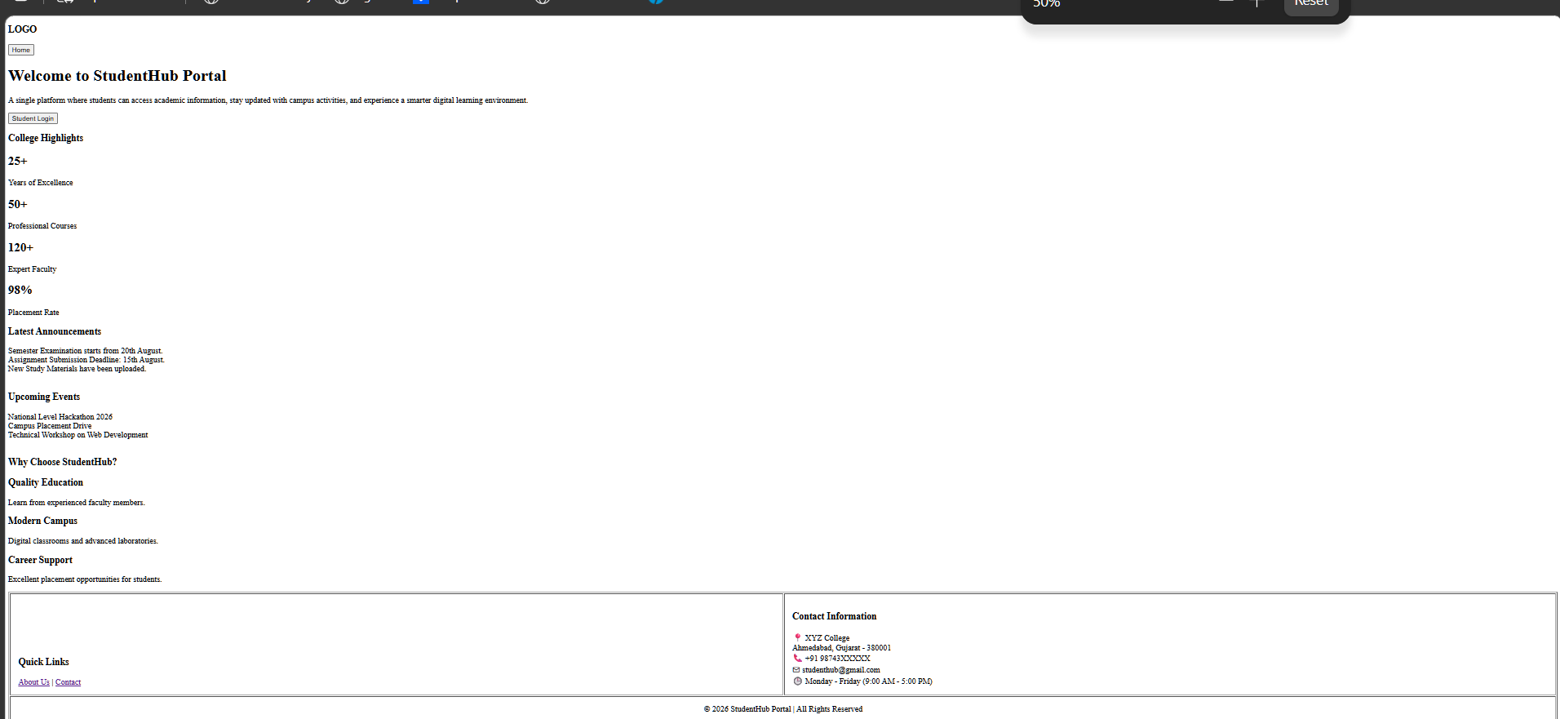
Figure 2.1: Home Page
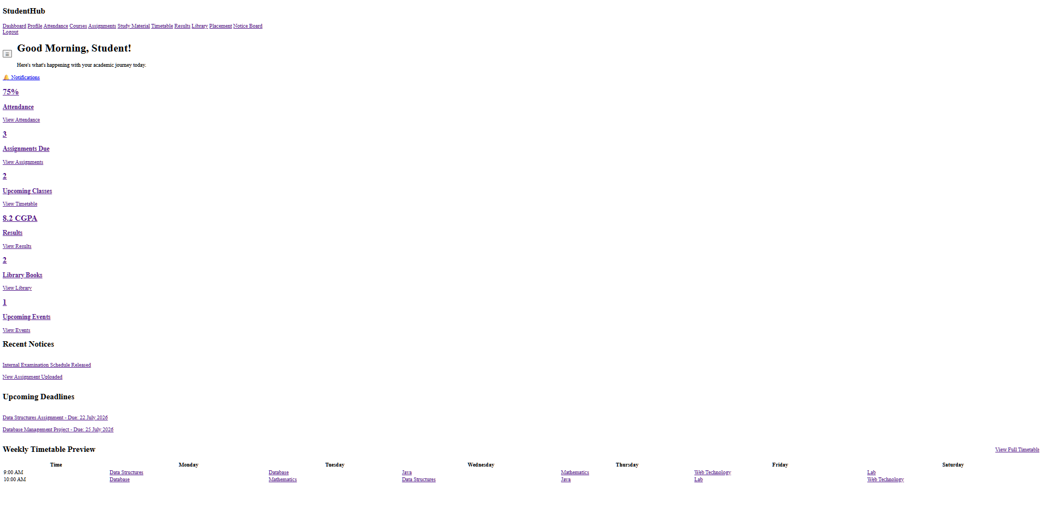
Figure 2.2: Dashboard Page

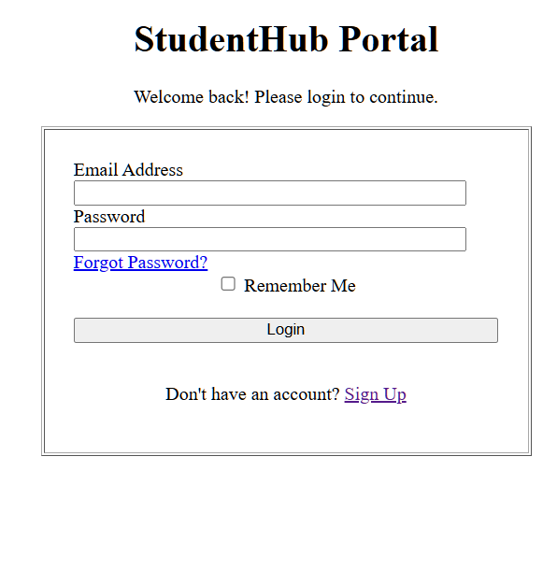
Figure 2.3: Login Page
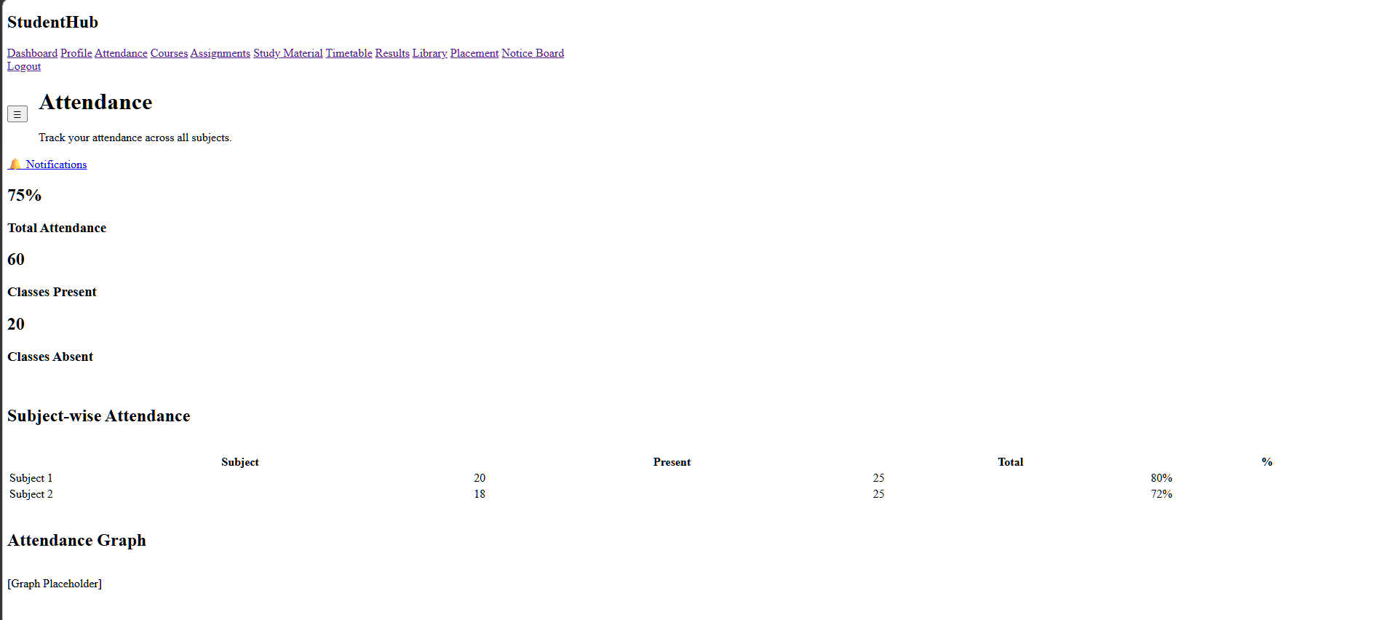
Figure 2.4: Attendance Page
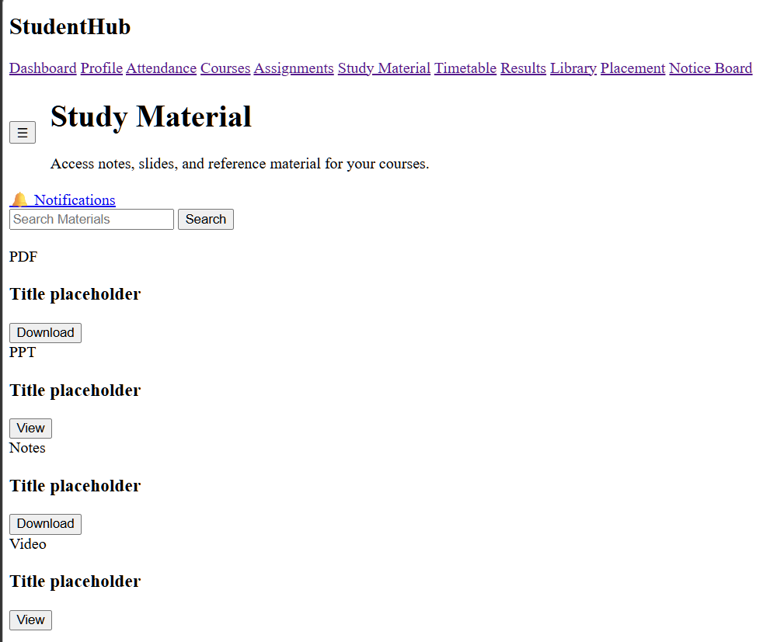
Figure 2.5: Study Material Page
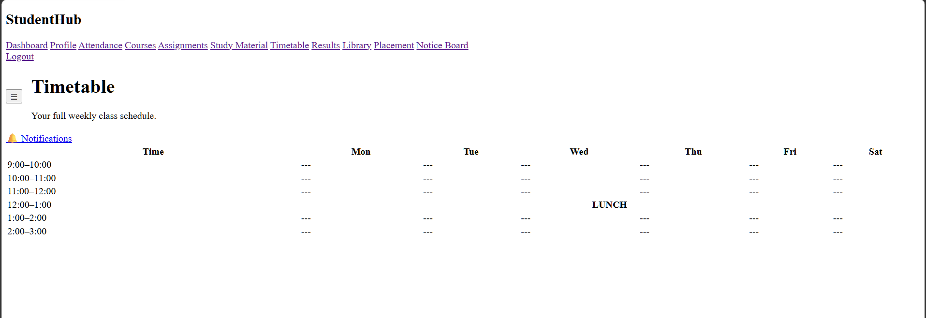
Figure 2.6: Timetable Page
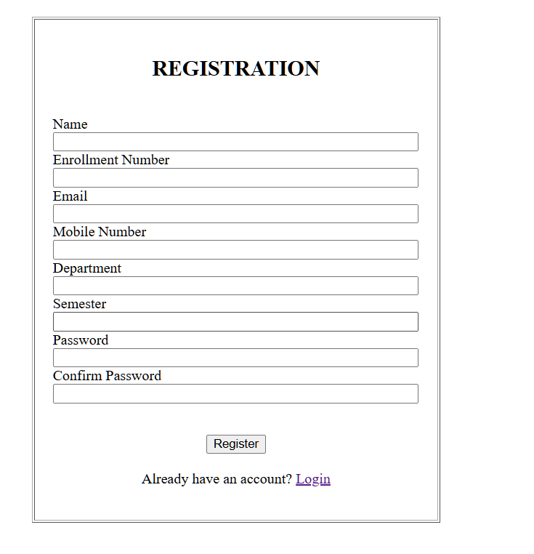
Figure 2.7: Register Page
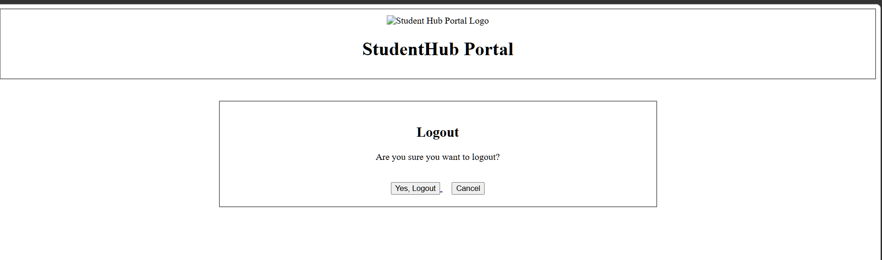
Figure 2.8: Logout Page

GitHub Repository Link: https://github.com/shahmahi0717/Student-Hub-Portal

Challenges Faced:
- Creating 10+ HTML pages and maintaining the same structure across them.
- Linking pages like Home, About, Login, Register, Dashboard, and Events correctly.
- Creating the sidebar/navigation menu on different pages.
- Managing the logo and StudentHub Portal header properly.
- Creating forms for Login, Registration, Contact, and Feedback pages.
- Maintaining proper HTML structure and semantic tags.
- Fixing issues where some links or page elements were not working properly.
- Keeping the HTML code organized so it could be easily connected with CSS later.

Learning Outcomes:
- Learned to create multiple HTML5 web pages.
- Understood the use of semantic HTML tags.
- Improved page structure and navigation skills.
- Learned to create basic forms and user input fields.
- Understood the importance of accessibility in web design.

Faculty Remarks: (Keep this blank for faculty)

